HOSTEL FEEDBACK REPORT ANALYSIS

Hostel Name : ………………………., Devi Ahilya University, Indore

Location : ………………………….., Devi Ahilya University, Takshshila
Campus, Khandwa Road, Indore-452001.

Session : Jan. 2013 to June 2013.

Section A: Hostel Facilities

1. Room hygiene | 2. Furniture availability (eg Almirah, Table, Chair)
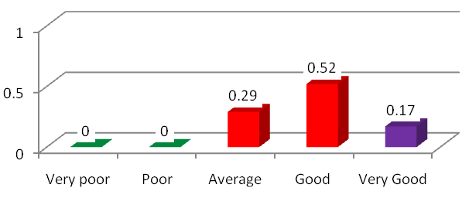 | 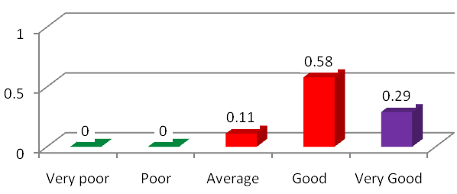
3. Corridor arrangements (eg Light, cleaning) | 4. Toilet (eg Light, water)
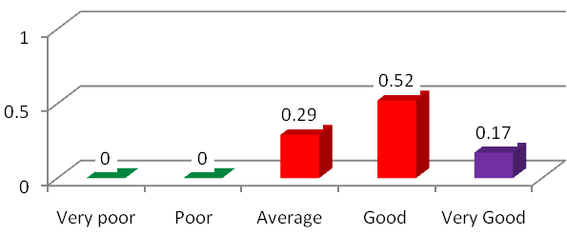 | 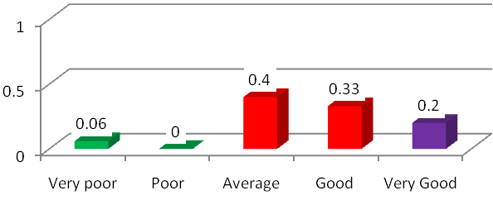
5. Recreation Facilities (eg TV) | 6. Sport facilities (eg Gym, Outdoor, Indoor)
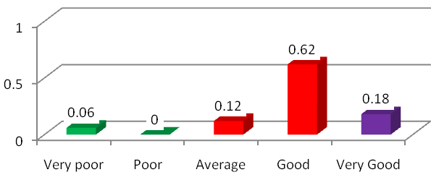 | 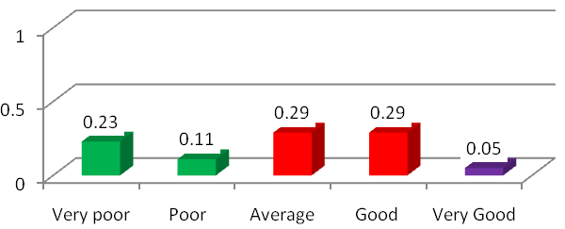

7. Library Facilities (eg Newspaper, Magzine) | 8. Internet Facilities
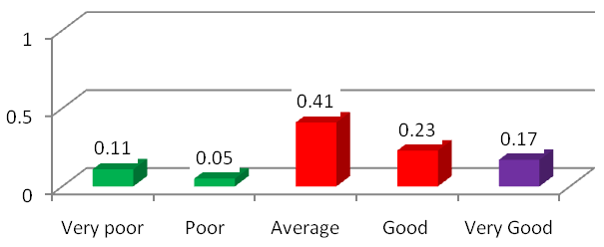 | 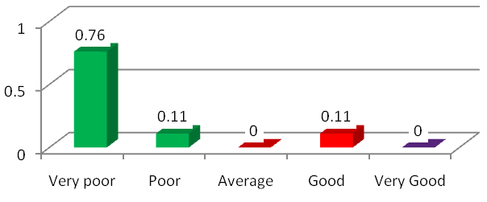
9. Hostel surroundings (eg Garden, Hygiene) | 10. Overall living facilities
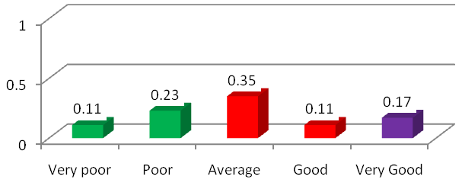 | 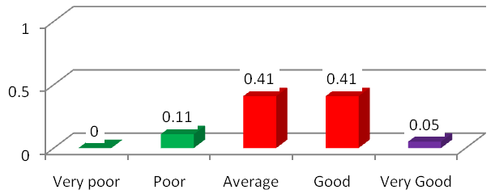

Section B: Mess Facilities

1. Service by contractor, staff | 2. Quality of food
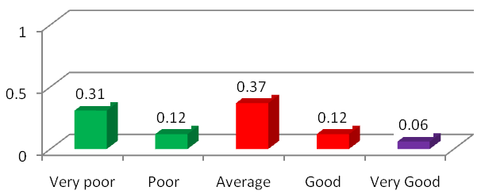 | 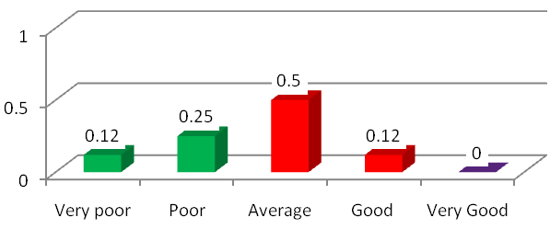
3. Kitchen and Dining Hall Hygiene | 4. Variety in meal
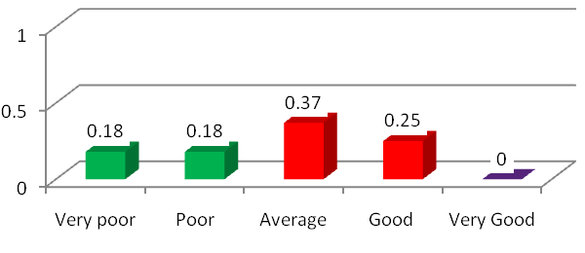 | 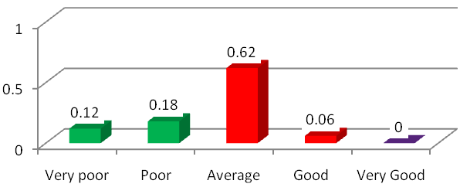

5. Cost of meals | 6. Drinking water (eg Aquaguard, filter etc.)
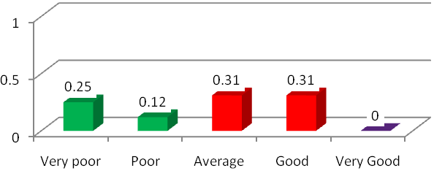 | 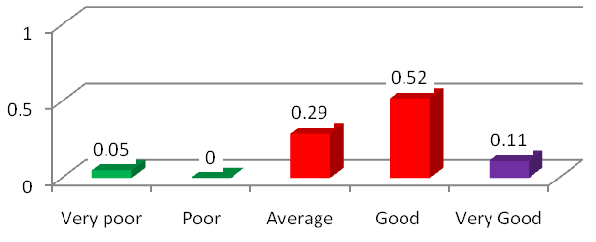
7. Timing of mess | 8. Students Participation
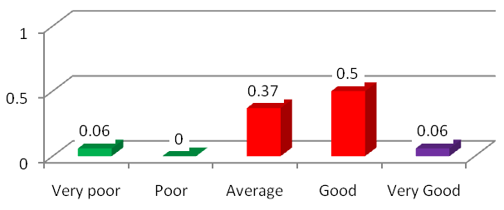 | 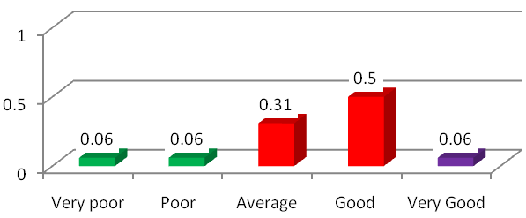
9. Seating Arrangement | 10. Insect removal arrangement
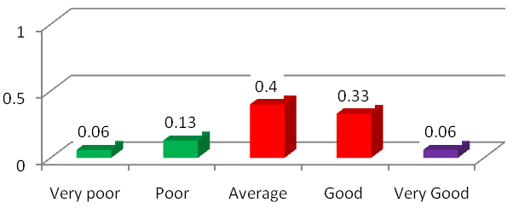 | 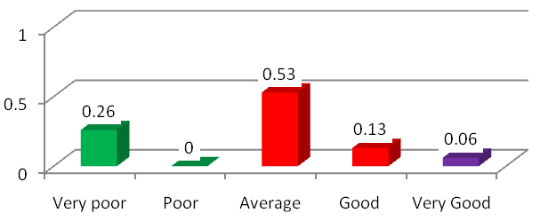

Section C: Warden, Staff and Medical Doctor

1. Attention on problems | 2. Visits by warden
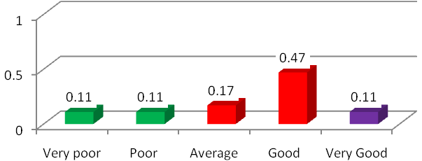 | 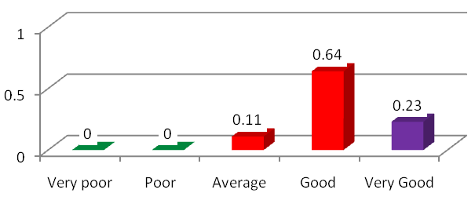

3. Visit/Facility by Medical Doctor in Hostel

3. Accessibility | 4. Behaviour of hostel staff
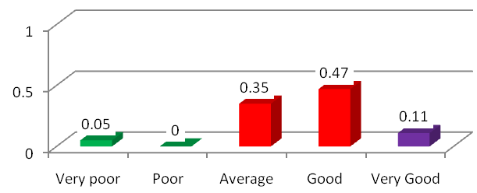 | 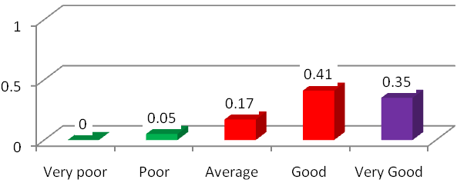
5. Overall Rating
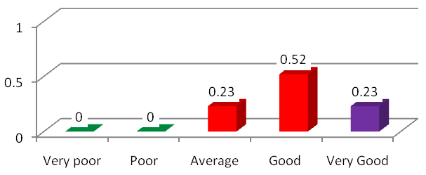

Section D: Comments

01. Good points (Write in capital letters): Hostel location, suitable atmosphere for study, supportive staff, TV facility, peaceful, good staff and good atmosphere.
02. Weak Points (Write in capital letters): Cleaning problem, no internet facility, limited sports facility.
03. Any other complaints/suggestion: Internet facility should be provided at earliest.

